MACH4METAL

Metalworking machinery
Transito 21,
6909 DA BABBERICH
Netherlands
Tel. +31 (0)316 – 247123
Fax. +31 (0)316 - 247956
info@mach4metal.com
www.mach4metal.com

Account No: 66.52.13.883
IBAN : NL33 INGB 0665 2138 83
BIC : INGBNL2A

AUERBACH Bed milling machine
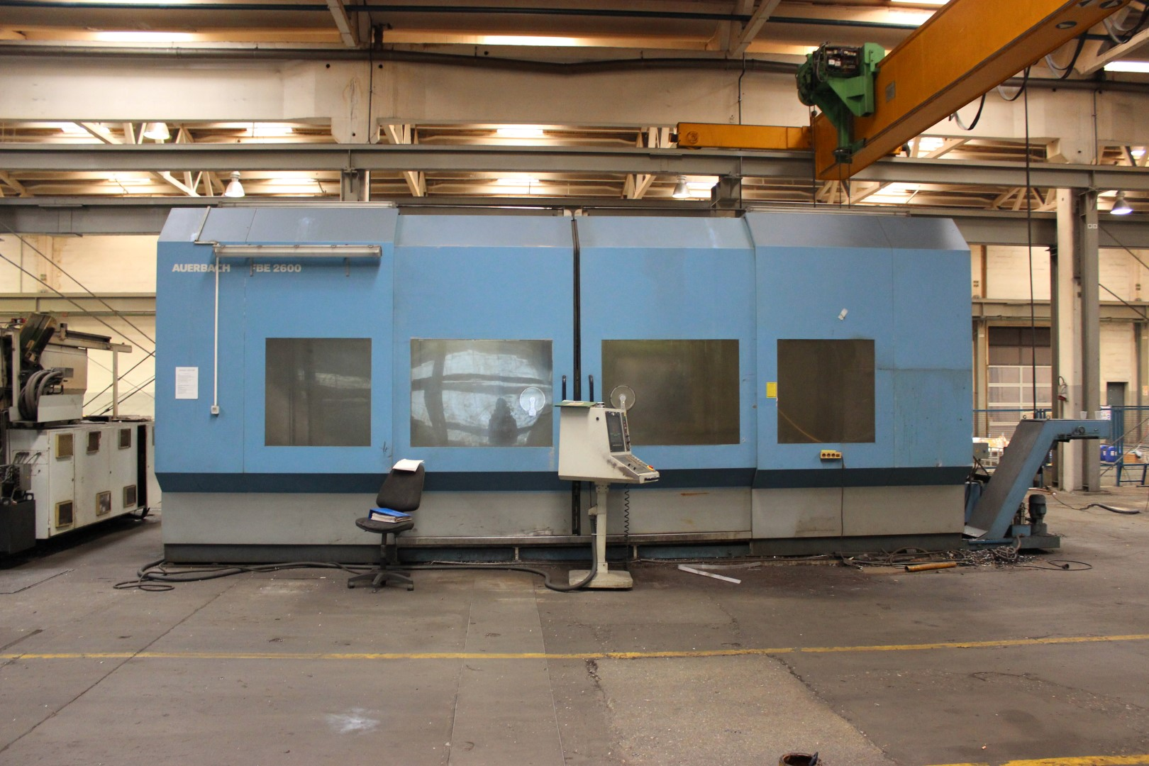
- Make : AUERBACH Germany
- Typ : FBE 3000
- No : 028
- Age : 1999

- Capacity
- X travel : 3.000
- Y travel : 865
- Z travel : 1.500

- Table length : 3.100
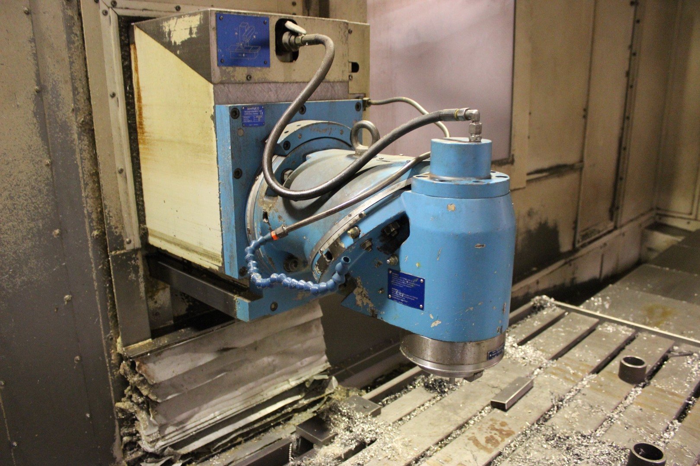
- Table width : 800
- Table load : 10.000

- Spindle speeds : 30 – 3500
- Power : 29 kW
- Feed rate : 6.000 mm/Min

- Distance head – table : 33 – 933
- Distance head rot. – table : 98 – 998

- Rebuild automatic head rebuild in 2014
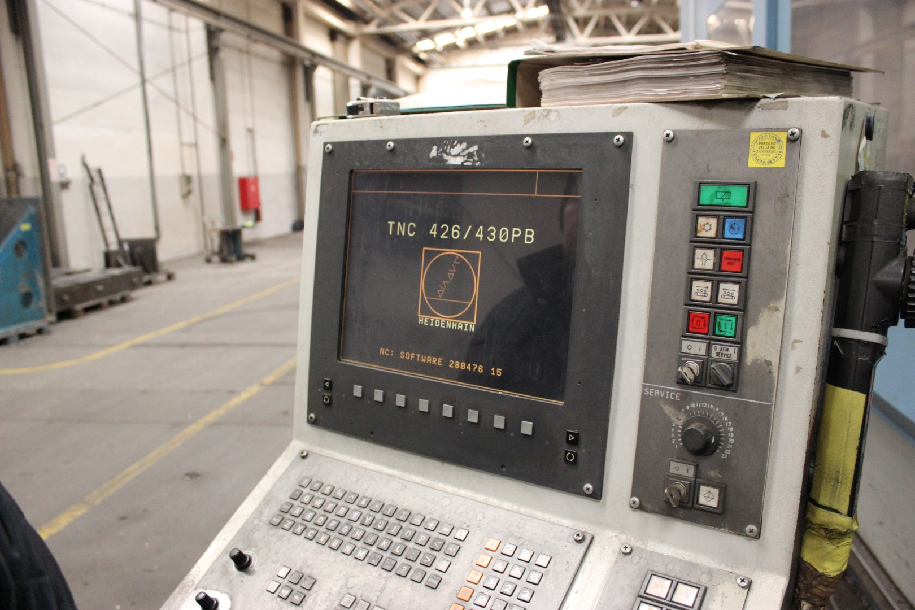
SEMPUCO model KFUD 3/010
Automatic 90 Gr. head 360 x 1˚
Automatic 45 Gr. head 360 x 1 ˚

- Dimensions
- Length : 9.710
- Width : 5.500
- Height : 3.650
- Weight : 19.5 T

Please Note: The above information has been obtained to the best of our ability and belief from, and from the manufacturers where possible. It is given in good faith, but its accuracy can not be guaranteed. Accordingly,it will not form a representation or constitute contractual terms. We advise you to check any vital details!

MACH4METAL

Metalworking machinery
Transito 21,
6909 DA BABBERICH
Netherlands
Tel. +31 (0)316 – 247123
Fax. +31 (0)316 - 247956
info@mach4metal.com
www.mach4metal.com

Account No: 66.52.13.883
IBAN : NL33 INGB 0665 2138 83
BIC : INGBNL2A

AUERBACH Bed milling machine
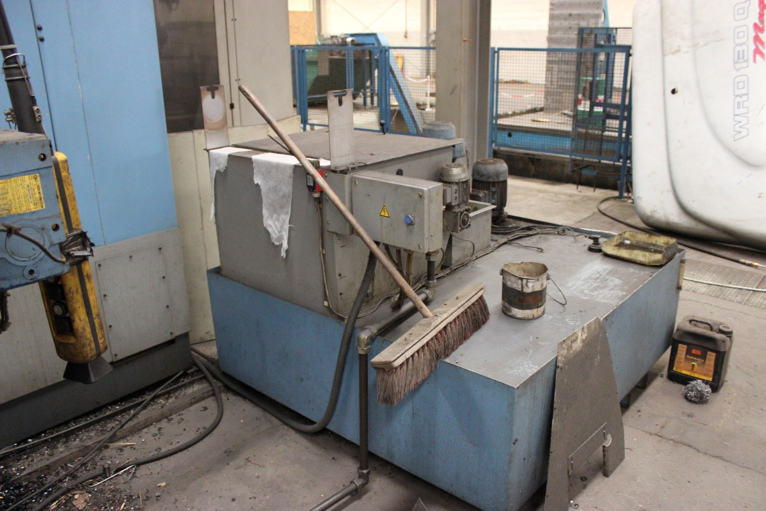
- Power total : 42 kW
- CNC HeidenHain TNC 426 / 430
- HeidenHain Handwheel HR 410
- Heidenhain TS 632 – 3D measure

- Tool changer 72 positions
- Tool length : 250
- Tool diameter : 125 Ø
- Tool weight : 150 Kg
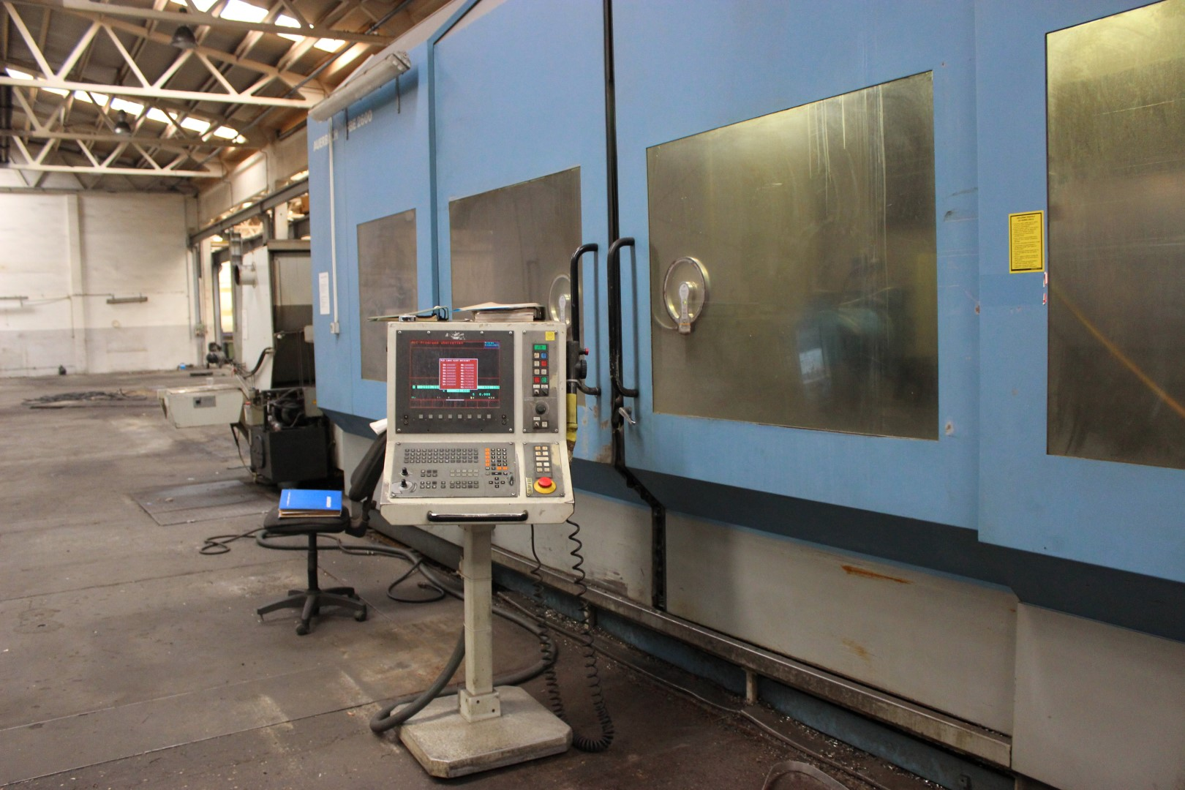
- Chip conveyor on full length
- Height off “output “ : 1.100

- DGS high pressure coolant
- Paper filtration
- Capacity : 30 Bar

- 4e axis WALTER RTWN 250
- Diameter : Ø 355
- Height : 250

Please Note: The above information has been obtained to the best of our ability and belief from, and from the manufacturers where possible. It is given in good faith, but its accuracy can not be guaranteed. Accordingly,it will not form a representation or constitute contractual terms. We advise you to check any vital details!

